Syncing current production sites to D8 (e.g. for US site):
- Import / Export current production US site’s database
Reference: https://confluence.icrossing.com/pages/viewpage.action?pageId=1791557863
- Create new database for US site in D8 and update settings.php file. e.g. database name: ix8_us
- Installed Drupal and enabled required modules (Drupal 8.5.6)
- OR - import the 856_install_structure.sql and configure it with Drupal 8.5.6
Path: {drupal root dir}/db
- Update the composer.json and run composer update form command prompt
"require": {
"composer/installers": "^1.0.24",
"wikimedia/composer-merge-plugin": "^1.4",
"drupal/search_api_solr": "^2.0",
"drupal/console": "1.3.1",
"league/csv": "^8.2",
"drush/drush": "^9.3",
"solarium/solarium": "^3.8"
},

- Empty following tables from D7’s database
- All cache tables
- menu_custom, menu_links and menu_router
- Run /upgrade and click on Continue button
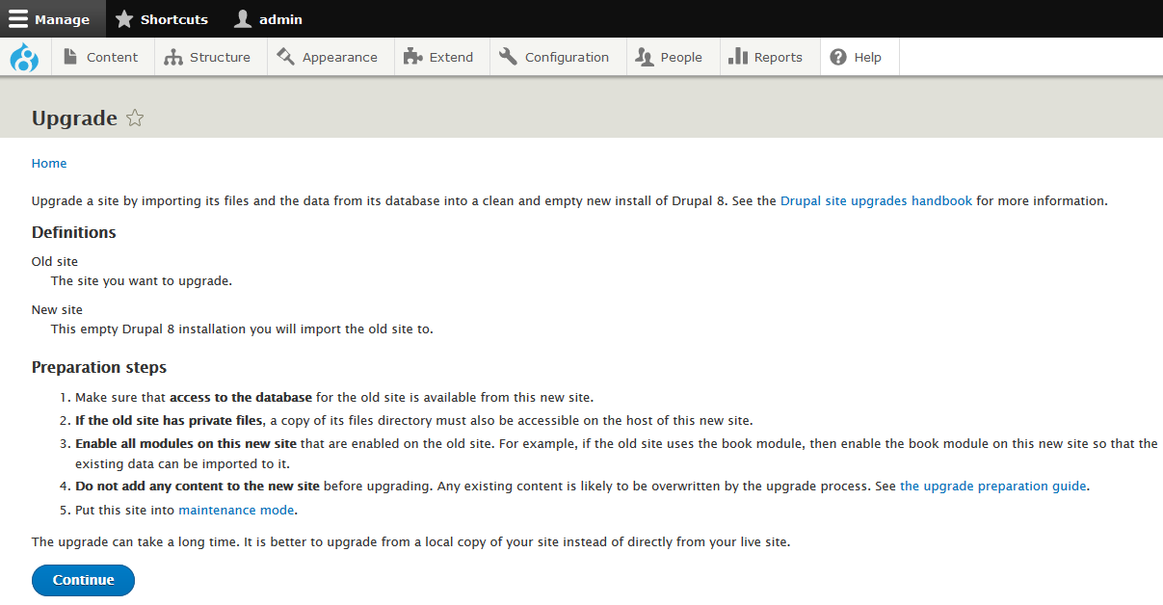
- Step 2: following are local configuration; then click on Review upgrade
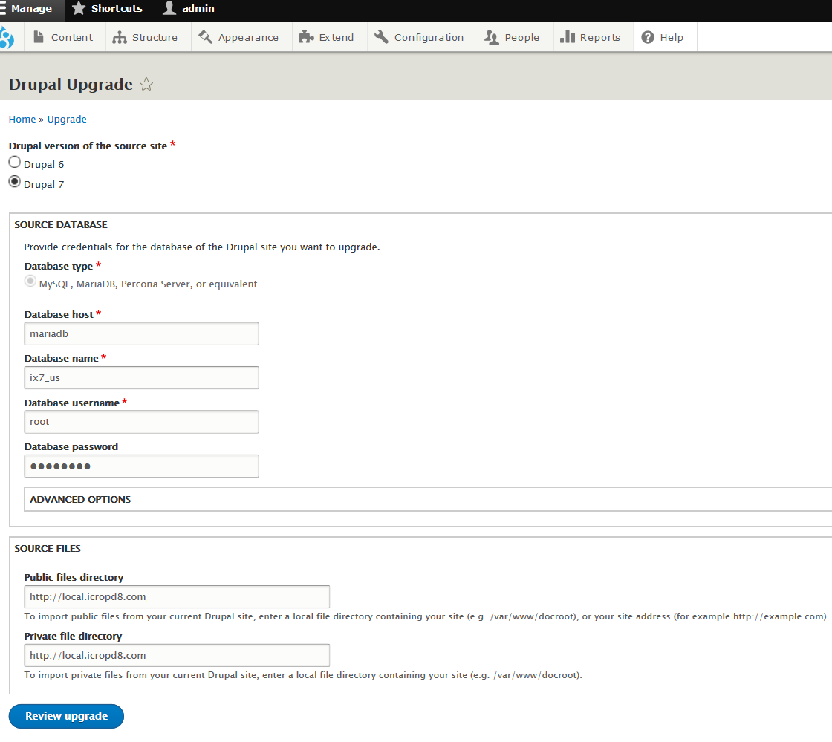
- Step 3: Click on Perform upgrade
- Wait for next 10-15 mints: Screen - Running upgrade
- Enable the following custom modules and default theme
- Custom Modules: Case Studies, Custom vbout api, Custom Xcode Module, Homepage Image Rotation, Icrossing Generic, ixSearch form blocks, Xcode
- Contributed modules: Search API, Search pages, Solr search
- Themes: iCrossing Theme, zen (set iCrossing Theme as default)
- Uninstalled core Search, BigPipe, Quick Edit modules
- Go to Block structure and disabled ‘Broken/Missing, <none>, and other custom modules’ blocks for Admin theme (Seven and iCrossing Theme)
- For importing Us site configurations
- Copy and extract us_site_configuration.tar.gz under modules/features directory
- wwwroot\modules\features\ us_site_configuration.tar.gz
- Got to features configuration page
- /admin/config/development/features
- Click on Feature name
- Click on import missing (check ‘Configuration missing from active site’) and cleared all cached
- Cross-checked all content types fields settings e.g. manage form display and managed display
- Download and override files folder for D7’s product site
- Configure settings.php file, please refer following local settings
- $settings['file_public_base_url'] = 'http://local.icropd8.com/sites/default/files';
- $settings['file_public_path'] = 'sites/default/files';
- $settings['file_private_path'] = 'sites/default/files/private-files';

- Trusted host settings:
e.g. $settings['trusted_host_patterns'] = array (
'^local.icropd8.com',
'^localhost'
);
- Enabled Memcached module and update setting.php with following configuration:
//Memcache configurations
// Set’s default cache storage as Memcache and excludes database connection for cache
$settings['cache']['default'] = 'cache.backend.memcache';
$settings['cache']['bins']['render'] = 'cache.backend.memcache';
$settings['cache']['bins']['dynamic_page_cache'] = 'cache.backend.memcache';
// Set’s Memcache key prefix for your site and useful in working sites with same memcache as backend.
$settings['memcache']['key_prefix']= 'ixcom_us';
$settings['memcache']['persistent'] = TRUE;

- Configured theme and blocks and cleared all cached
- Check the block configuration for iCrossing Theme, delete unwanted blocks and cleared all cached
e.g. Delete Title, Site branding, Main navigation, User account menu, Status messages, Secondary navigation, Tools, Help, Footer menu, Powered by Drupal, etc
- Check the all content types manage fields, display settings, etc configurations: Added field groups and rearranged fields as per requirements.
- Migrate missing fields e.g. field collections, images and metatags, etc
  - Configured Base set URL and Sites files path
Path: admin/config/custom_xcode/settings
e.g. http://local.ix8.com:8081/ and /sites/default/files/
  - Drupal 7 sites: Enabled ‘Node export dependency’ module and export all nodes into json files (Node export (JSON))
  - Drupal 8: Migrate missing content from custom form and import them
Path: xcode/xform
- Done.

